**Project Report Template**

**Title of Project:** Child Abuse Awareness Campaign  
**Name of the Innovator:** Ruthu Devaraj Poojary  
**Start Date:** 27-10-2025

**End Date:** 31-10-2025

***Day 1: Empathise & Define***

*Step 1: Understanding the Need*

* Which problem am I trying to solve?

I’m trying to solve a problem as Many people (especially parents, teachers, and even children) don’t know how to identify **early signs of abuse** or where to report it safely. There’s also a lack of accessible**, trustworthy resources for education, emotional support, and action**, so my platform helps them get personal guidance.

* Who is affected by this problem?
* How did I find out about this? [Select whichever is applicable]
* Interviews
* Observation
* Online Research
* AI Tools

*Step 2: What is the problem?*

The problem is that Child abuse is a serious issue that often **goes unnoticed or unreported**. Many children suffer from **physical, emotional, or sexual abuse**, but they are **afraid to speak up** or don’t know how to get help.

Why is this problem important to solve?

Child abuse causes **severe emotional, mental, and physical harm** that can affect a child’s entire life. **Raising awareness and providing support** are essential to **protect children’s rights**, encourage reporting, and **build a safer society** for every child.

**Take-home task**

Ask 2-3 people what they think about the project:

* **1. Student (Rural College Student):**  
  “This project helps us understand what child abuse really means. Many students don’t even know that some behaviors are abuse. It’s good that this app teaches us how to protect ourselves and others.”
* **2. Teacher (Career Guidance Teacher):**  
  “It’s a very meaningful project. As teachers, we sometimes notice changes in students’ behavior but don’t always know how to respond. An awareness app like this can help educators identify signs early and guide students to safety.”
* **3. Parent (From a Rural Area):**  
  “Every parent worries about their child’s safety. This project reminds us to talk openly with our kids and be aware of what they’re going through. It’s a great idea that helps both children and parents.”
* ”

*AI Tools you can use for Step 1 and 2:*

**AI Tools Used:**

**1. Meta MGX**

* Used to generate creative **media content such as posters, visual concepts, and awareness graphics** for the campaign.
* Helped in enhancing design ideas **by suggesting layouts, color schemes, and emotional** imagery related to child protection.
* Assisted in **visual storytelling, making the awareness message** more impactful through AI-driven design support.

**2. ChatGPT**

* Used to research and write **content for posters, app prompts, and awareness** messages in clear, empathetic language.
* Helped in structuring the project, including **defining the problem, importance**, and proposed solution effectively.
* Assisted in idea generation and **report writing, saving time and improving** the overall quality of communication materials.

**3.Web Application Reference**

* Childline India Foundation – National helpline and awareness platform for children in distress.
* National Commission for Protection of Child Rights (NCPCR) – Government body for child rights awareness and protection policies.
* Save the Children India – NGO that works to prevent child abuse and promote child

Welfare.

***Day 2: Ideate***

*Step 3: Brainstorming solutions*

* List **at least 5 different solutions** (wild or realistic):
* **Safe guard App (Realistic)-** A mobile app that teaches children and parents about abuse, lets users report anonymously, and connects them to child helplines.
* **AI Chatbot Counselor (Realistic/Wild)-** An AI-powered chatbot that talks to children safely, identifies emotional distress through conversation, and suggests trusted help or support services.
* **Virtual Reality (VR) Experience (Wild)-**A VR-based awareness program that helps parents, teachers, and students understand what abuse looks like and how to respond in real-life scenarios.
* **School Awareness Program (Realistic)-** Workshops, digital posters, and role-play sessions in schools to teach children about their rights, personal safety, and how to ask for help.
* **Social Media Campaign with AI Posters (Realistic/Wild)-**An online campaign using AI tools (like DALL·E or Canva AI) to create emotional, visually powerful awareness posts encouraging “Speak Up, Save a Child.”

*Step 4: My favourite solution:*

My favourite solution is the **Safe guard** App because it combines education, technology, and safety in one platform.The app helps children, parents, and teachers learn about different forms of abuse, recognize warning signs, and report incidents safely and anonymously.

*Step 5: Why am I choosing this solution?*

I am choosing the **Safe guard** App because it is a modern and effective way to reach people of all ages.Most children, parents, and teachers use smartphones, so an app can easily spread awareness, teach safety tips, and offer instant help when needed.

*AI Tools you can use for Step 3-5:*

**AI Tools for Step 3–5**

**1. Meta MGX**

* Helped in creating **visual ideas** like **posters and campaign graphics** for child abuse awareness.
* Used **to generate design layout**s and color themes that match the emotional tone of the project.
* Assisted in enhancing creativity by **providing AI-based visual suggestions** and media elements

**2. ChatGPT**

* Used to write clear and emotional content for posters, app descriptions, and awareness messages.
* Helped in structuring the project report, including the problem, importance, and solutions.
* Supported idea generation and language refinement for a more professional and meaningful presentation

**3. Web application Reference**

* Childline India Foundation – Offers real-life resources and helpline information for child protection.
* UNICEF Child Protection – Provides global awareness materials and data on preventing child abuse.
* Save the Children India – Shares campaigns, stories, and community programs that inspired this project.

*AI Tools you can use for the take-home task:*

**Canva AI / Adobe Firefly**-Assisted in designing digital posters and infographics with AI-generated templates.

**ChatGPT (by OpenAI**)-Helped in writing and organizing content for the report, posters, and app idea.

***Day 3: Prototype & Test***

*Step 6: Prototype – Building my first version*

What will my solution look like?

* **Home Screen:** Welcomes the user and asks for basic information
* **Quick Access Buttons (Main Menu Grid)-**Anonymous safe chat with trained volunteers or AI counselor.
* **Awareness Banner (Center Section)-**A rotating carousel that auto-slides between 3–5 slides that gives motivational quotes.
* **Interactive Section (Optional but Engaging)**-“Did You Know?” corner — one short awareness fact daily.
* **Accessibility & Safety Features**-Large, clear icons child-friendly Audio assistance for users with reading difficulties.

**Design Style:**

* Simple, intuitive, and easy to navigate for youth.
* Bright and engaging visuals to make learning and Access
* Mobile-friendly layout for easy access on smartphones.

**Prototype Tools:**

* Built using **Meta MGX**, no coding required, with all features **interactive and testable**.

What AI tools will I need to build this?

**AI Tools Needed to Build are:**

1. **Meta MGX**
   * No-code platform to **design and deploy the app**.
   * Allows building **interactive screens, chat interfaces, and skill modules** without coding.
2. **ChatGPT (or similar LLMs)**
   * To **generate content, conversation flows, and User friendly responses**.
   * Can help **personalize recommendations** for users based on their profile and problems.
3. **AI Chatbot Design References**
   * **Google Dialogflow / IBM Watson Assistant / Microsoft Bot Framework**
   * To **structure conversation logic** and handle user queries effectively.
4. **AI Recommendation Tools** *(Optional but useful)*
   * For matching students with their problems and **to assist them with solutions** and actions
   * Could use **different location** provided platforms

What AI tools I finally selected to build this solution?

1. **Chat GPT**
2. **Metamgx**

**Tool Link:**  <https://mgx-3a8g6ohynqr.mgx.world>

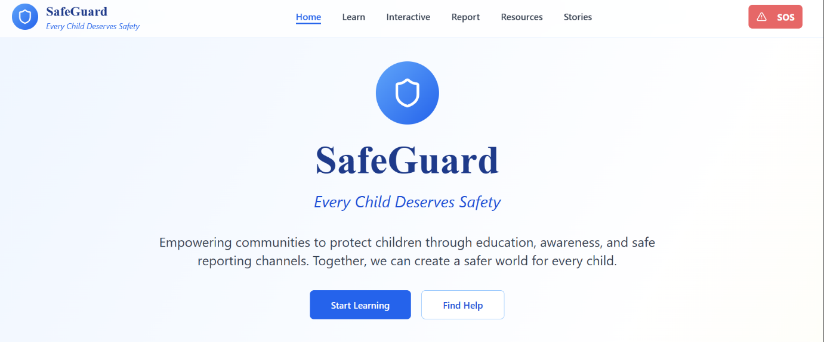

Internal Working of tool:

Profile Creation:

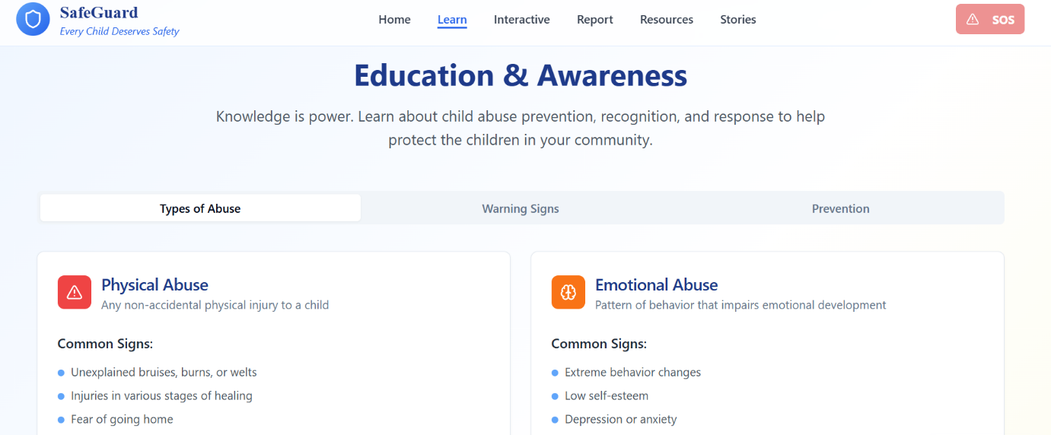

Tailoring recommendations for Interactive sessions

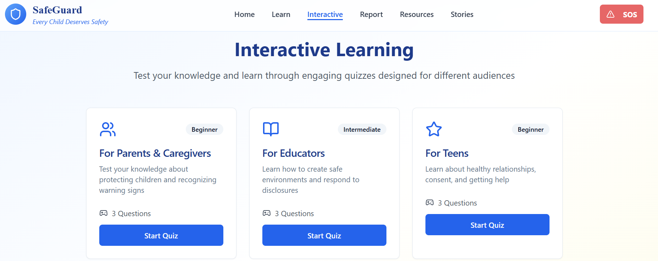

Security and Safety based on Registered Profile:

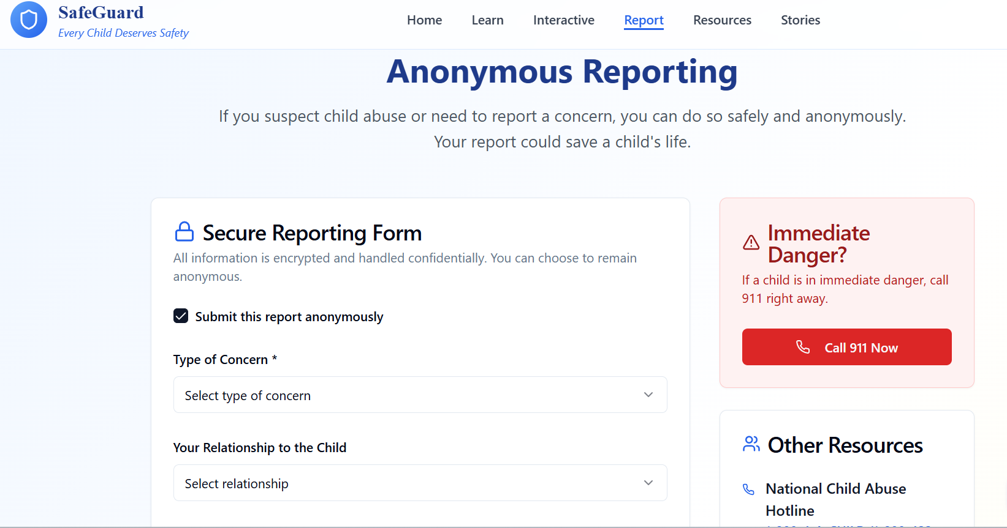

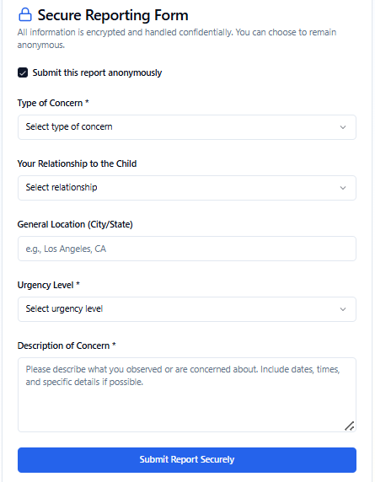

Resources and helpline based on profile:

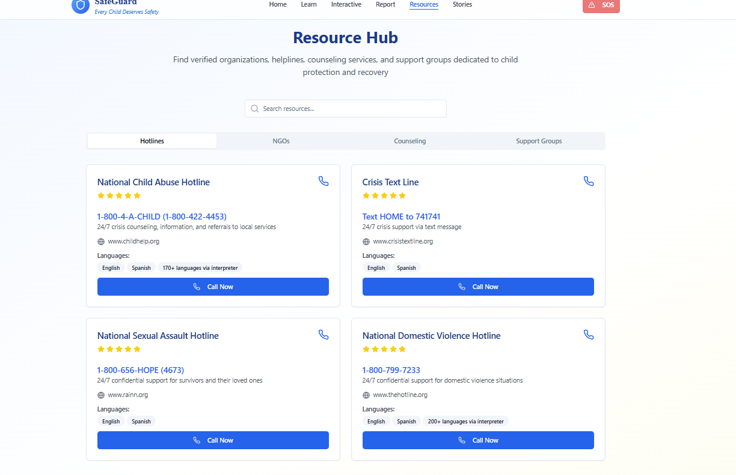

*Step 7: Test – Getting Feedback*

* Who did I share my solution with?

I shared my Child Based Awareness Campaign solution with:

* **Students from rural areas** – to get feedback on usability and relevance.
* **Teachers and career guidance counselors** – to understand how well it supports every age group.
* **Parents of rural students** – to see if it helps families access information about safety and guidance.
* **Peers and mentors** – for suggestions on improving features and design.

What feedback did I receive?

**Feedback: Pros and Cons**

**Pros (Positive Insights from Feedback):**

1. Spreads Awareness:Helps children, parents, and teachers **understand the signs of abuse** and how to prevent it.
2. Provides Easy Access to Help:Users can quickly reach helplines or **report abuse safely** through the app.
3. Encourages Education and Action:Promotes **open conversations** and empowers communities to **protect children.**

**Cons (Areas to Improve Noted in Feedback):**

1. Limited Internet Access:Some users, especially in rural areas, **may not have smartphones** or **stable internet** to use the app
2. Privacy Concerns:Users may worry about their **personal data or reports** being shared without consent.
3. Dependence on Technology:Relying too much on the app **may reduce direct human interaction** and emotional support.

**My Response for The Feedback:**  
I really appreciate the feedback I received about my **Safe guard** App project. It helped me understand the importance of making the app more interactive, user-friendly, and accessible for all users. I learned that adding features like Ai guidance, location-based helpline support, and awareness materials can make the app more useful and impactful. The feedback also encouraged me to focus on privacy and emotional support for victims, which is very important in this topic. Overall, the suggestions motivated me to improve my design and make the app a safe and trusted space for children, parents, and teachers.

👍 What works well:

**What Works Well**

* **Lifetime Access:** Users can access awareness materials, report options, and learning modules anytime without any extra subscription
* **No-Code Development:** The app is built on Meta MGX, which doesn’t require coding knowledge — making it easy to create, update, or modify content for awareness campaigns.
* **Personalized Guidance:** AI-powered tools like ChatGPT assist users with customized safety tips, learning materials, and emotional support recommendations.
* **Skill Building:** Interactive modules help children and parents learn communication, confidence, and self-protection skills effectively.
* **Location-Based Suggestions:** The app can show nearby child protection centers, NGOs, and helplines for quick access to real help.
* **Mobile-Friendly and Intuitive:** The design is simple, user-friendly, and works smoothly even in rural areas — ensuring accessibility for all users.

What needs improvement:

* **Chatbot Responses:** The AI chatbot sometimes gives general replies instead of personalized guidance. It needs better training to respond with emotionally sensitive and accurate answers for children and parents.
* **Interactive Features:** Some features (like games, quizzes, and reporting tools) are limited or not fully accessible in the prototype. Adding more interactive elements can increase engagement and learning.
* **Resource Integration:** The app can expand by connecting with real NGOs, helplines, and government resources to give users verified support.
* **Collaborations Needed:** Working with schools, child welfare organizations, and digital safety experts can make the app more trustworthy and widely used.
* **User Experience Enhancements:** The interface could be improved with better visuals, navigation, and multilingual support to make it more child-friendly and appealing.

*AI Tools you can use for Step 6-7:*

**ChatGPT/Perplexity AI/Claude AI/Canva AI/Chatling AI/Figma AI/Metamgx/Gamma AI**: You can use these tools to build solutions/models or mock-up dummy prototypes

***Day 4: Showcase***

*Step 8: Presenting my Innovation:*I am presenting Child abuse Awareness Campaign digital awareness and support platform designed to prevent and respond to child abuse.

It Features:

It aims to educate, protect, and empower children, parents, and teachers through technology

* **AI-Powered Virtual Assistant:** Provides emotional support, safety tips, and confidential guidance for children and parents.
* **Awareness & Learning Modules:** Interactive lessons on recognizing abuse, online safety, and reporting methods.
* **Location-Based Help**: Connects users with nearby child protection centers, helplines, and NGOs.
* **User-Friendly Interface**: Built on Meta MGX, ensuring easy navigation, multilingual access, and lifetime availability.

**Impact:** Child Abuse Awareness Campaign helps children stay safe, aware, and confident by providing the right information and quick access to help.It bridges the awareness and communication gap between victims, families, and authorities.The app also encourages community participation, helping create a society that actively protects and supports children.

**<SHOWCASE YOUR INNOVATION TO YOUR PEERS>**

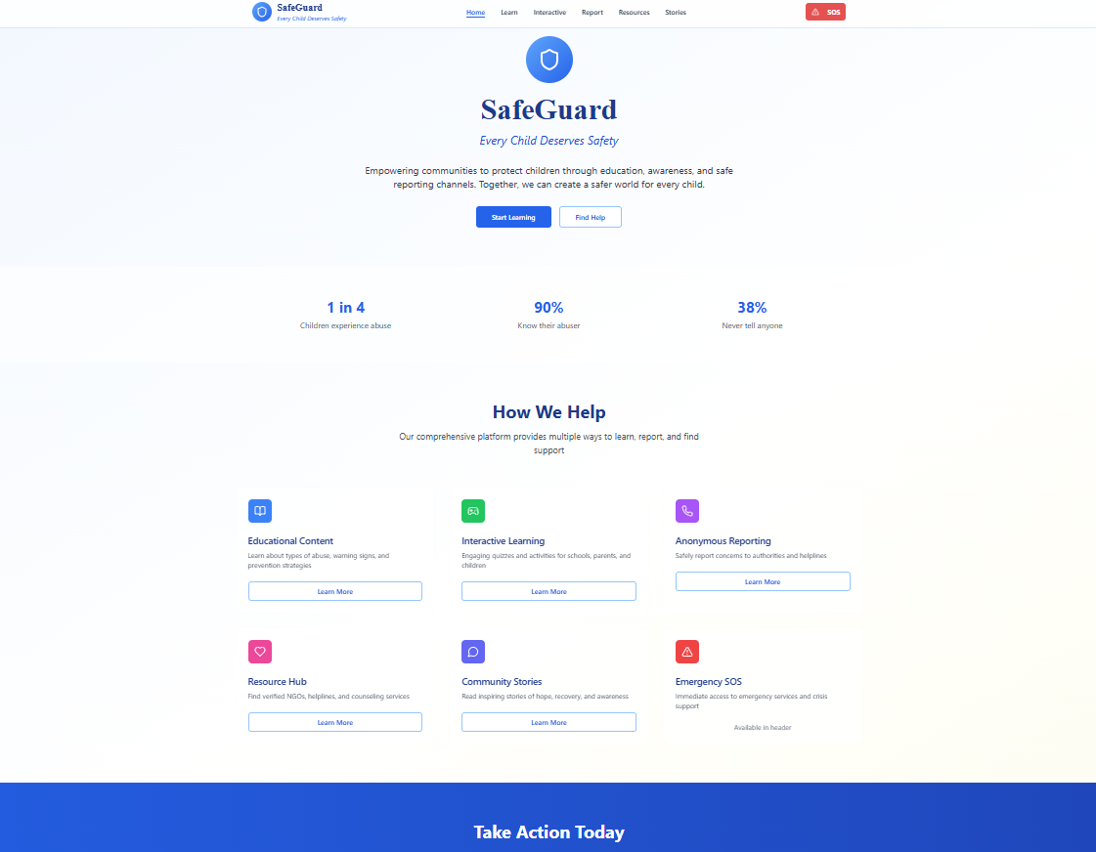

*Step 9: Reflections*

* What did I enjoy the most during this project-based learning activity?

I enjoyed the **creative part of designing the Safe guard App** the most. It was exciting to think like an app designer — choosing features, colors, and ideas that could really help children and families.

What was my biggest challenge during this project-based learning activity?

My biggest challenge was organizing all the ideas and turning them into a proper app design. Since the topic Child Abuse Awareness is very sensitive, I had to be careful with the language, content, and features to make sure it was respectful and supportive.

**Take-home task**

[*https://github.com/RUTHU17/Child-Abuse-Awareness-Campaign*](https://github.com/RUTHU17/Child-Abuse-Awareness-Campaign)

*AI Tools you can use for Step 8:*

**Canva AI:** You can use this to design your pitch document. Download your pitch document as a PDF file and upload on GitHub